TNotice minimal configurations

To send a request to SERC we must have information concerning both the sender and the receiver.

The sender will be set up as the Destinatario chosen when creating a new protocol. The receiver will be the POLAccount.

1. In the **PosteOnLineAccount** table the missing sender information will have to be manually inserted in the database for the accounts to be used

**Update [SM_Protocollo].[dbo].[PosteOnLineAccount] set ExtendedProperties = '{**

**"SercAuth": {**

**"AuthToken": "the auth code"**

**},**

**"SercExtra": {**

**"DatiTrasmissione": {**

**"IdTrasmittente": {**

**"IdPaese": "IT",**

**"IdCodice": "09268690964"**

**},**

**"ContattiTrasmittente": {**

**"NomeReferente": "fabrizio lazzarotto",**

**"TelefonoReferente": "06123456",**

**"EmailReferente": "fabrizio.lazzarotto@dgroove.it"**

**}**

**},**

**"Mitente": {**

**"Denominazione": "Denominazione del Mittente",**

**"Nome": "Beenear",**

**"Titolo": "Beenear",**

**"Cognome": "Beenear",**

**"Email": "anastasio.claudio@gmail.com",**

**"Sede": {**

**"Indirizzo": "Via Lombardia 17",**

**"NumeroCivico": 17,**

**"CAP": 31057,**

**"Comune": "Silea",**

**"Provincia": "TV",**

**"Nazione": "IT"**

**},**

**"Spedizione": {**

**"FirmaMessaggio": "true"**

**}**

**},**

**"Contratto": {**

**"Numero": 123457,**

**"Data": "2019-11-01"**

**},**

**"Fattura": {**

**"CodiceCliente": 84168,**

**"Sede": {**

**"Indirizzo": "Via Monte Baldo",**

**"NumeroCivico": 1,**

**"CAP": 20124,**

**"Comune": "Milano",**

**"Provincia": "MI",**

**"Nazione": "IT"**

**},**

**"EmailFattura": "fabrizio.lazzarotto@dgroove.it"**

**}**

**}**

**}**

1. The ProtocolContactManual has to have the following minimal information. These are required as part of the validation step before sending the documents and they are also used to populate the extended properties of the sender in the PosteOnLineContact

Minimal Fields for the receiver:

* FiscalCode, Address, CivicNumber, ZipCode, City, CityCode, TelephoneNumber, Email

The other fields for the sender are important only for the validation process in the Docsuite workflow

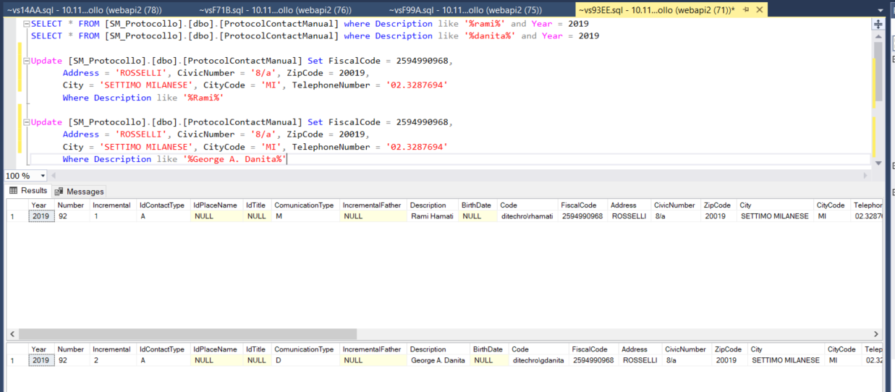

1. When the request is sent, 2 contacts are created in the table **PosteOnLineContact**, one for the sender and another one for the receiver.

From this table we need information about the receiver. In this table DocSuite will populate the ExtendedProperties with information table from the **ProtocolContactManual**. This will be accessed in the JeepService to create the xml needed for Serc.

